APPLICATION FOR TRAIL CONSTUCTION | 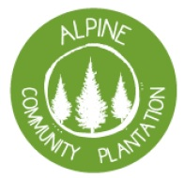
Trail Name:
Has this trail construction been approved by ACP?
Yes No
If yes please provide date of approval:
Trail Specifications
Grade: | Length:
Elevation Gain/Loss: -

Trail Construction Method:
This trail will be constructed according to the table below:
Task | Construction method | Approx Hrs
- Planning and detailed trail alignment marking  - Veg clearing (Blackberry and lower pine branch removal only)  - Initial bench establishment :  - Feature construction (including corners, berms, jumps etc)  - Rock armouring (as required)  - Final Shaping and drainage  - Construction of National level alternate lines | ACC volunteers  ACC volunteers  Contracted machine Contracted machine  ACC volunteers  ACC volunteers  ACC volunteers

Funding Overview
Total Funding Required:

Requirement of funding:

Other Funds:
ACC has allocated following funds to this trail project

